**Serverless Framework**

Reference: <https://serverless.com/framework/docs/getting-started/>

Installing as a Standalone binary

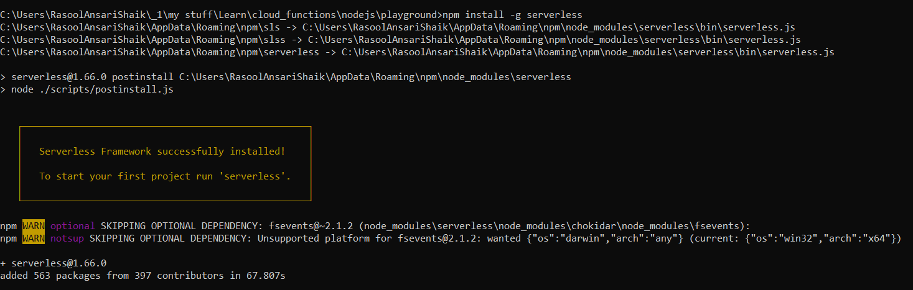

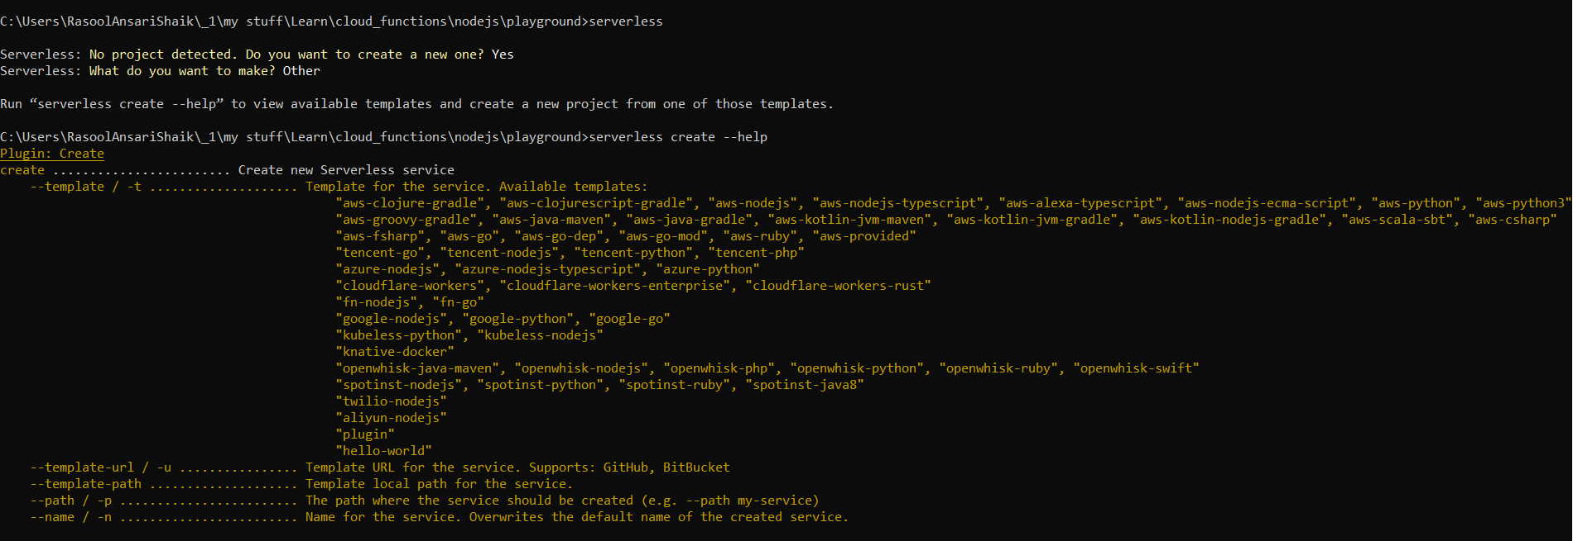

Create a serverless application using OpenWhisk in NodeJS

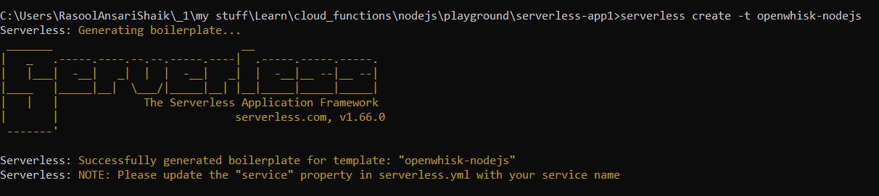

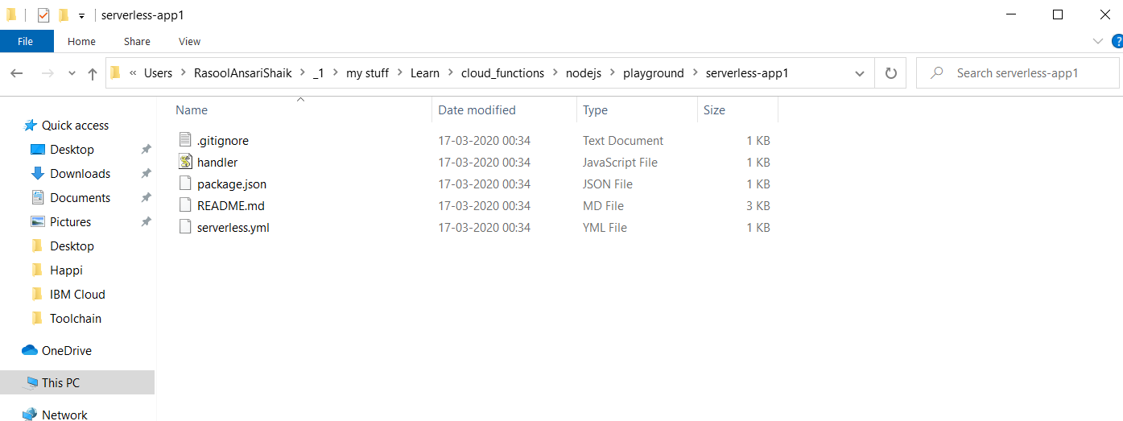

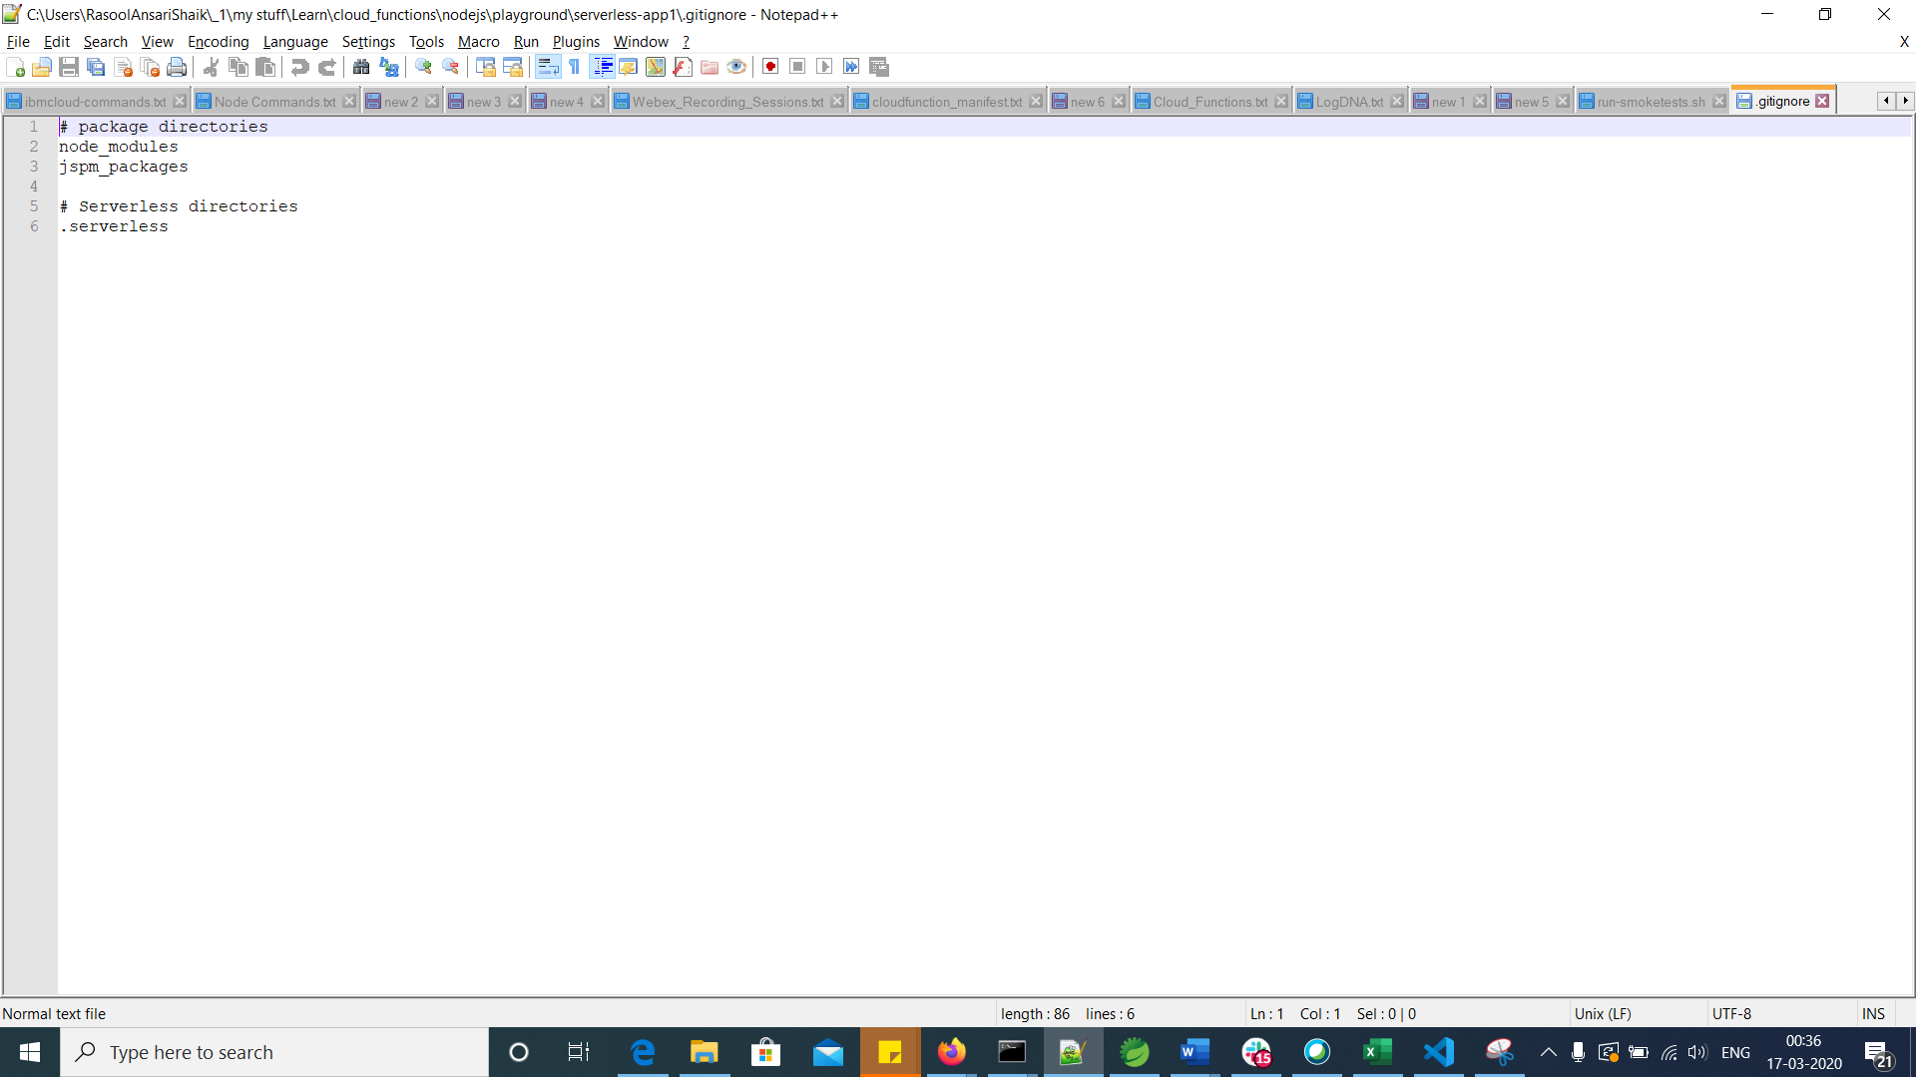

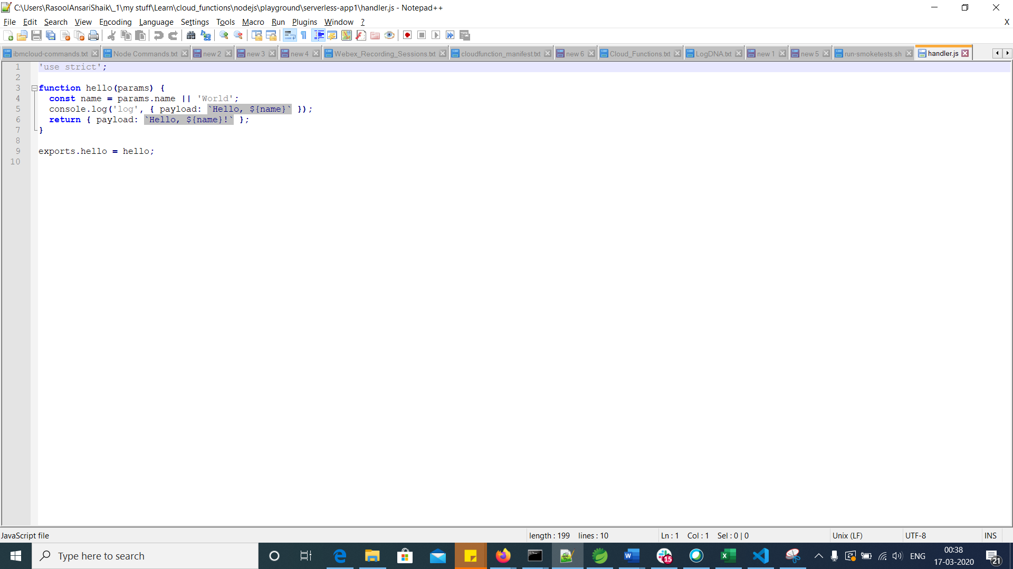

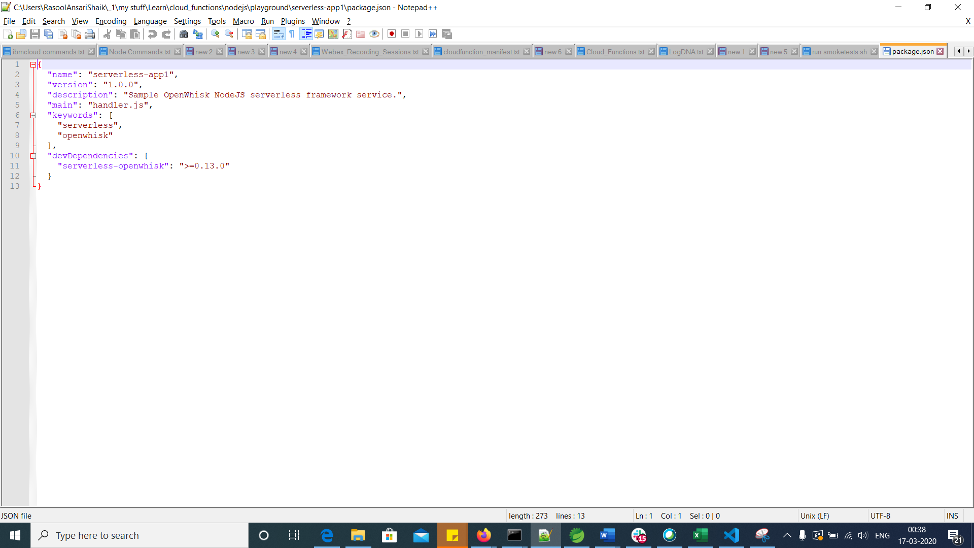

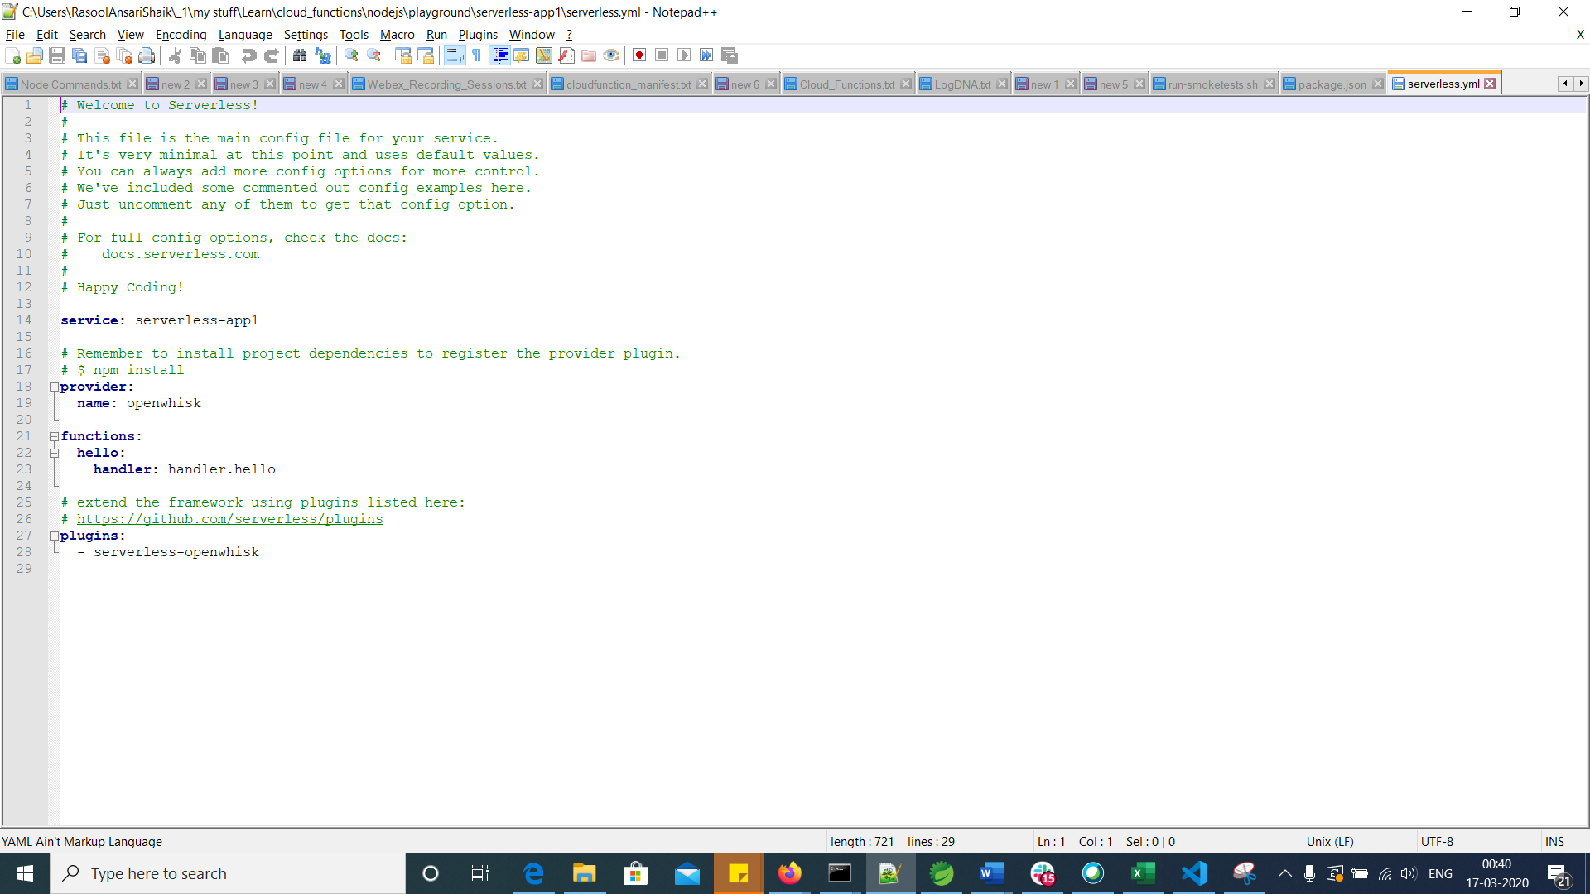

Deploy Application

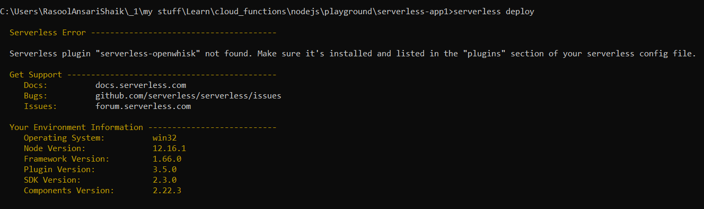

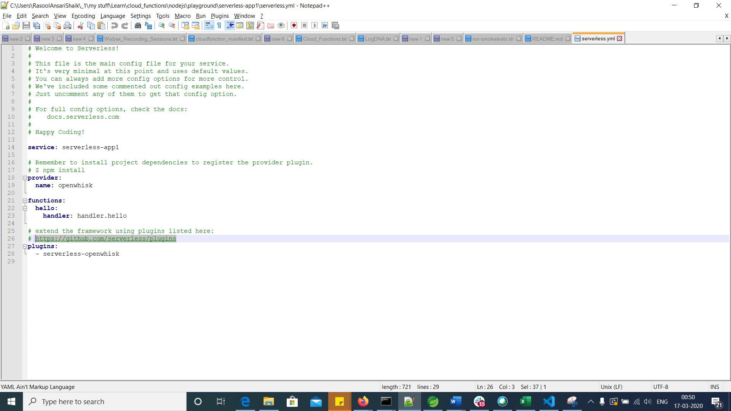

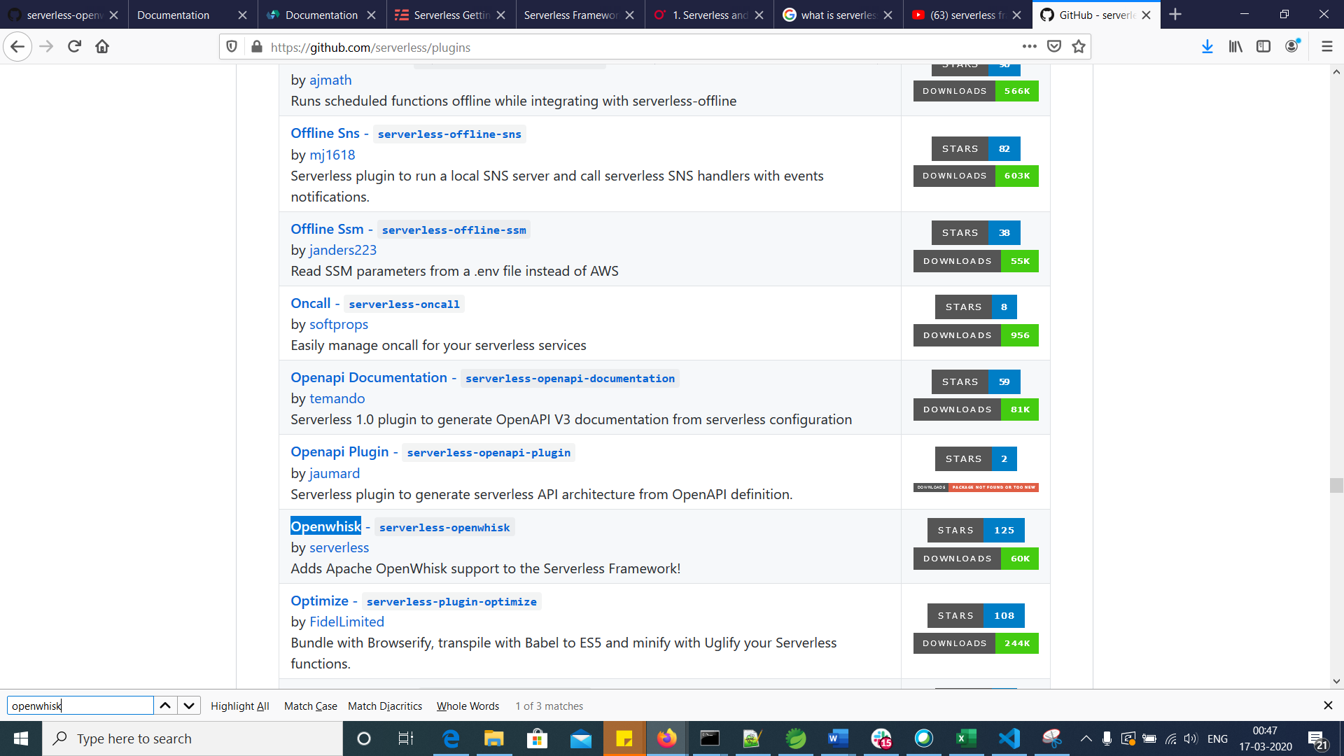

Reference: <https://github.com/serverless/serverless-openwhisk>

Login to IBM Cloud and target Resource group, Organization and Space

$ ibmcloud login –sso

$ ibmcloud target -g default -o [rashaik4@in.ibm.com](mailto:rashaik4@in.ibm.com) -s dev

$ ibmcloud fn list

Build NodeJS application using “npm install”, other wise we did not able to deploy the application.

PFA below error



Build application

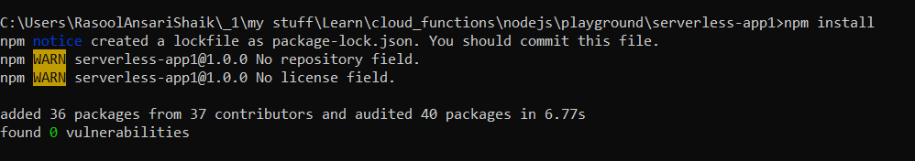

Deploy application

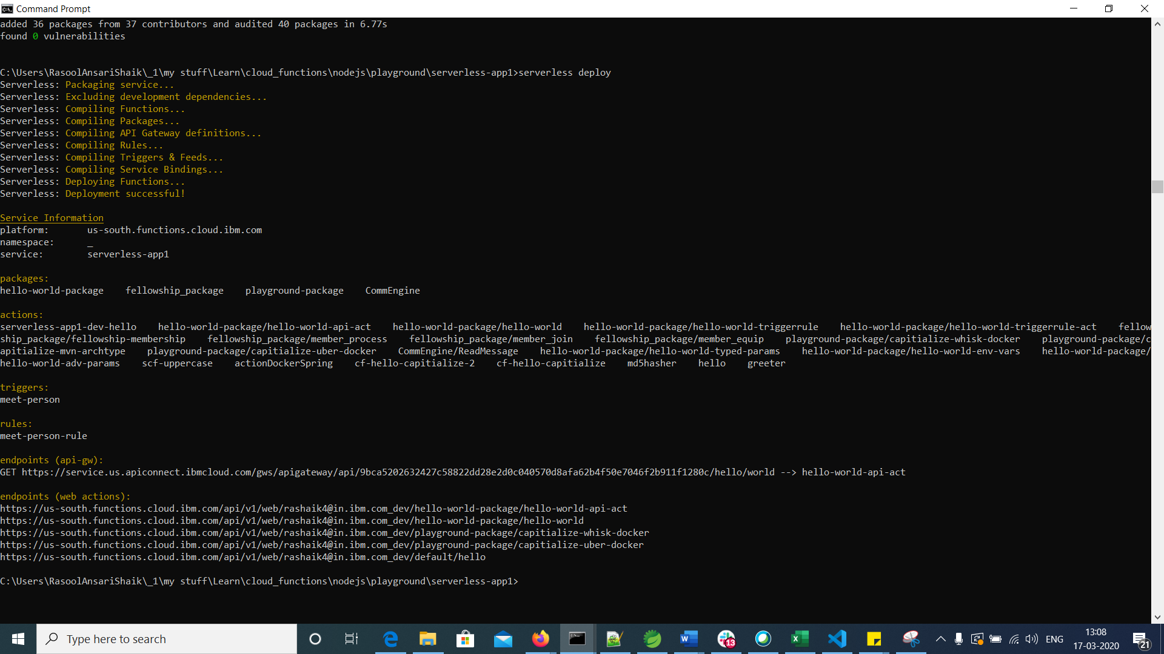

In IBM Cloud, the action created as “service_name + space + action_name” i.e., serverless-app1-dev-hello. PFB screenshot.

